parakeet communities
Signage Package
Sign Specifications · Installation Standards · Hardscape Guide
For Vendors, Contractors & Internal Team
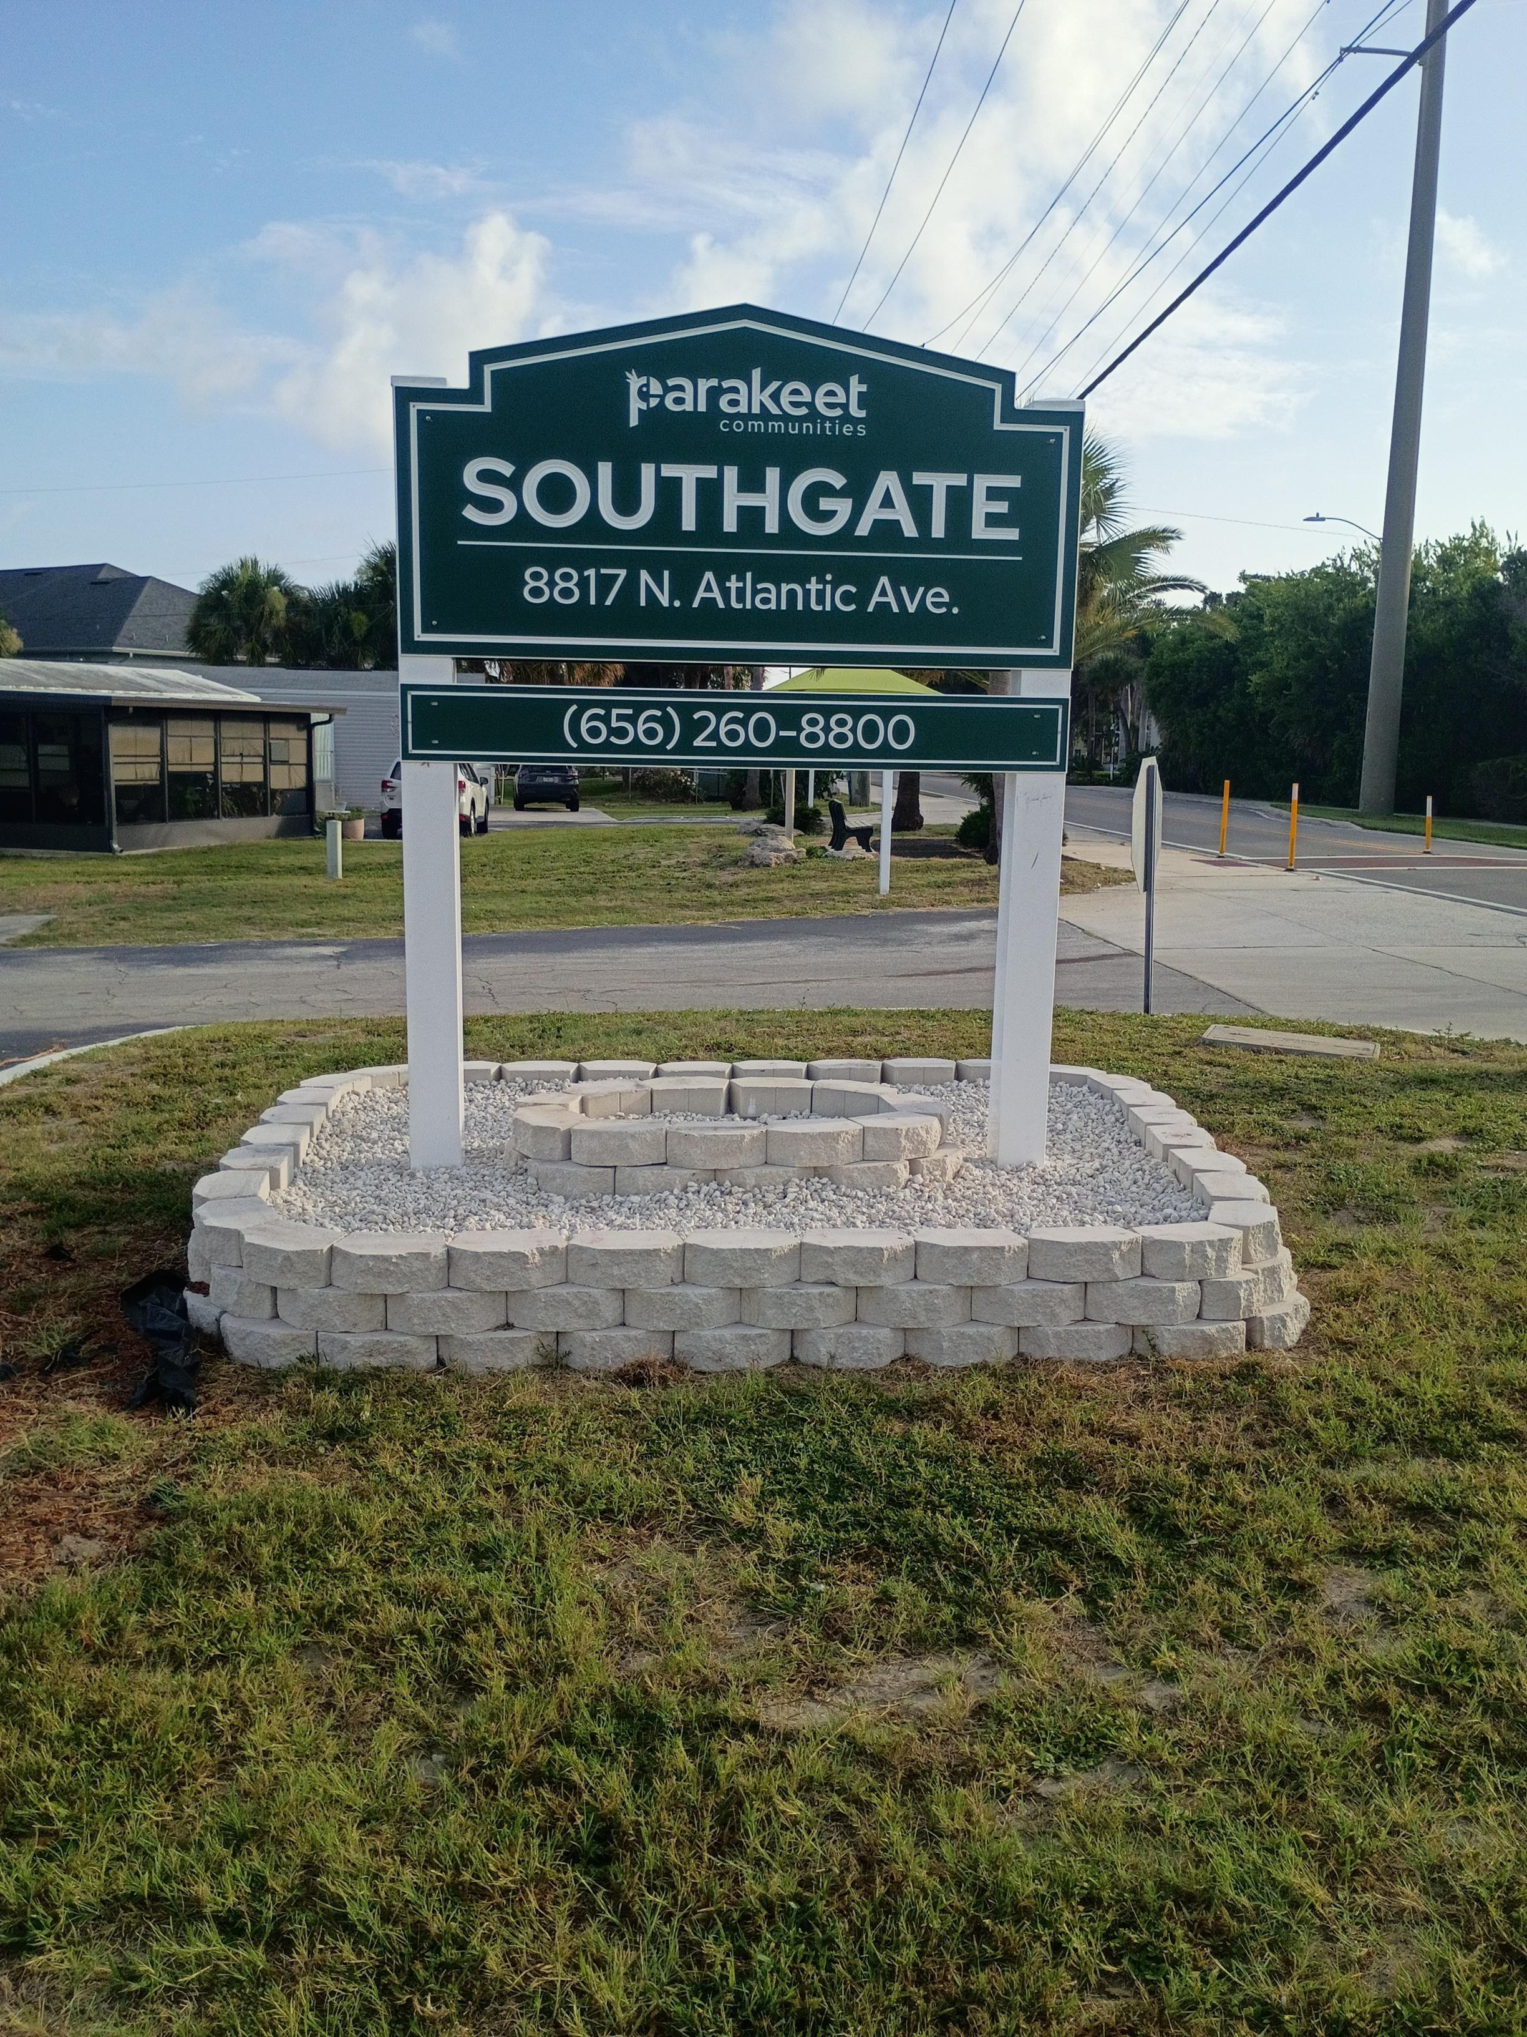

Section 1 — Sign Specifications

All signs are designed and fabricated by Elements, Inc. The drawings below are the approved specifications for each sign type used across Parakeet Communities properties.

Sign Type 1 — Main Entry Monument Sign

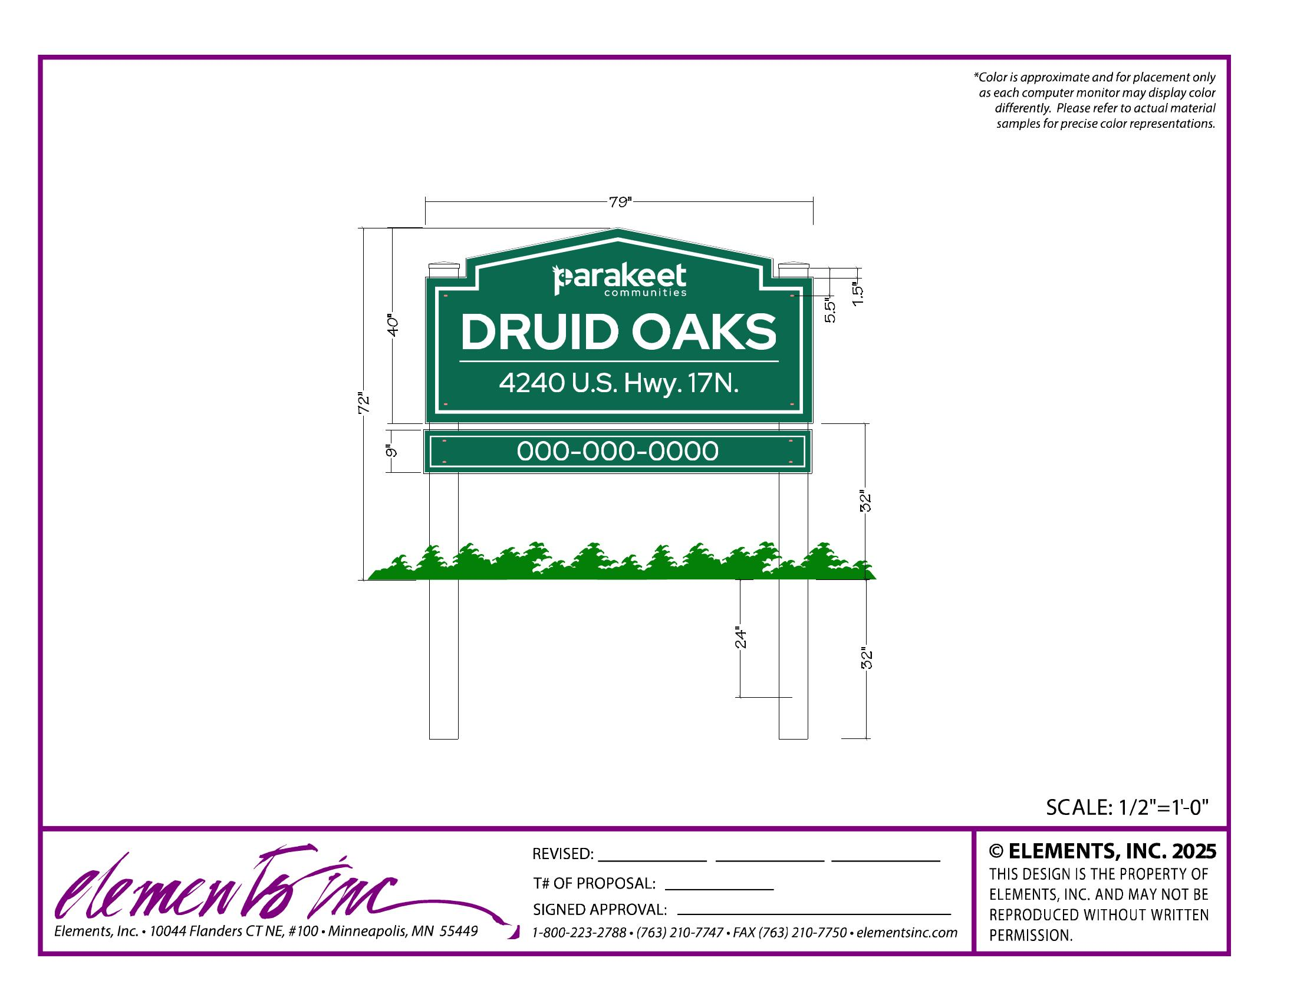
Main Entry Monument Sign — 79"W × 72"H face, 32" above grade, 24" below grade

Sign Type 2 — Community Office Sign

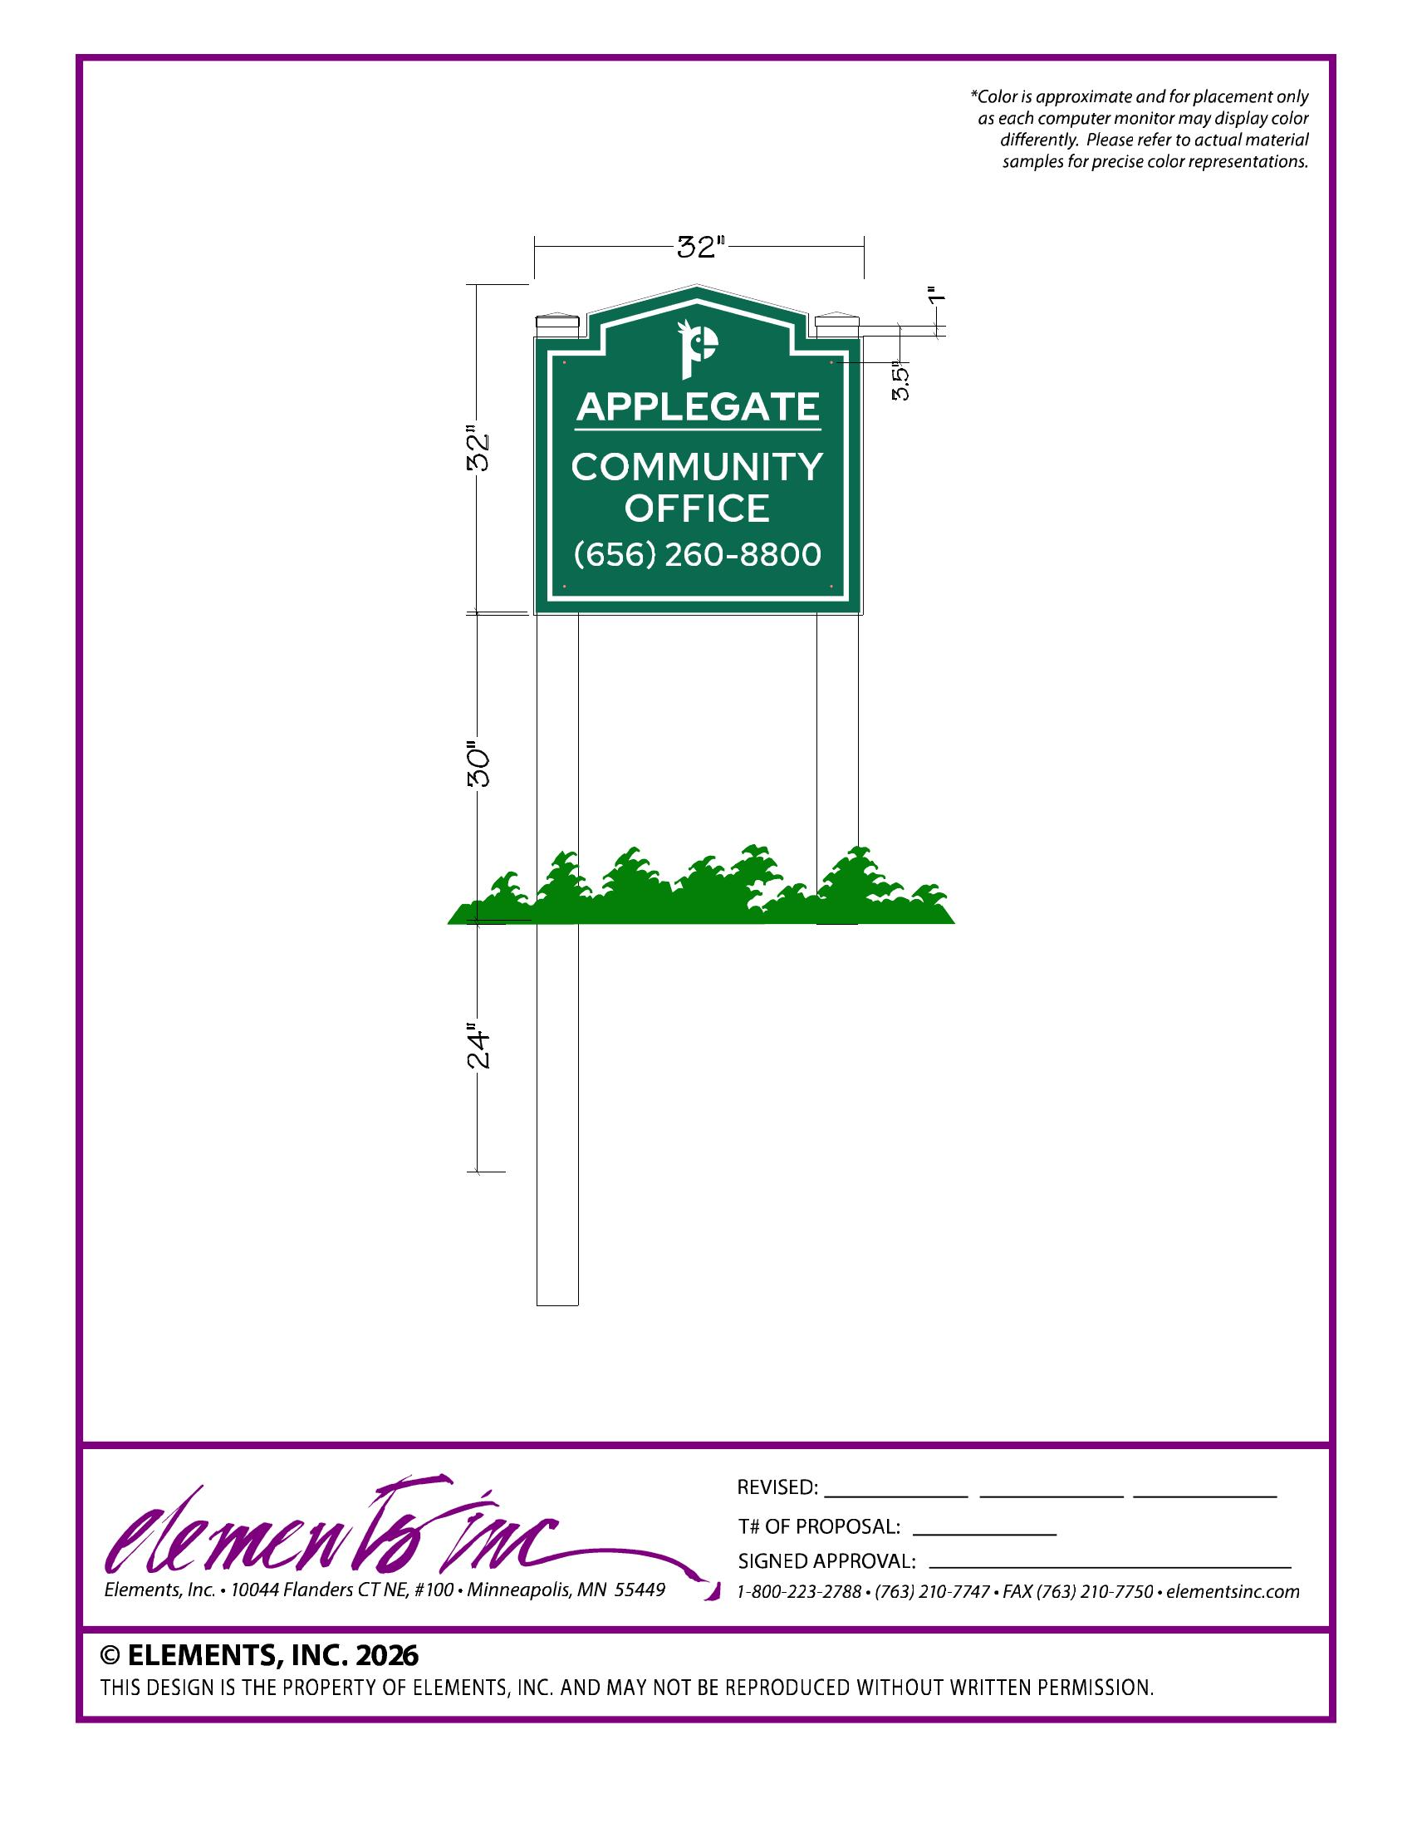
Community Office Sign — 32"W × 32"H, 30" above grade, 24" below grade

Sign Type 3 — Private Property Sign

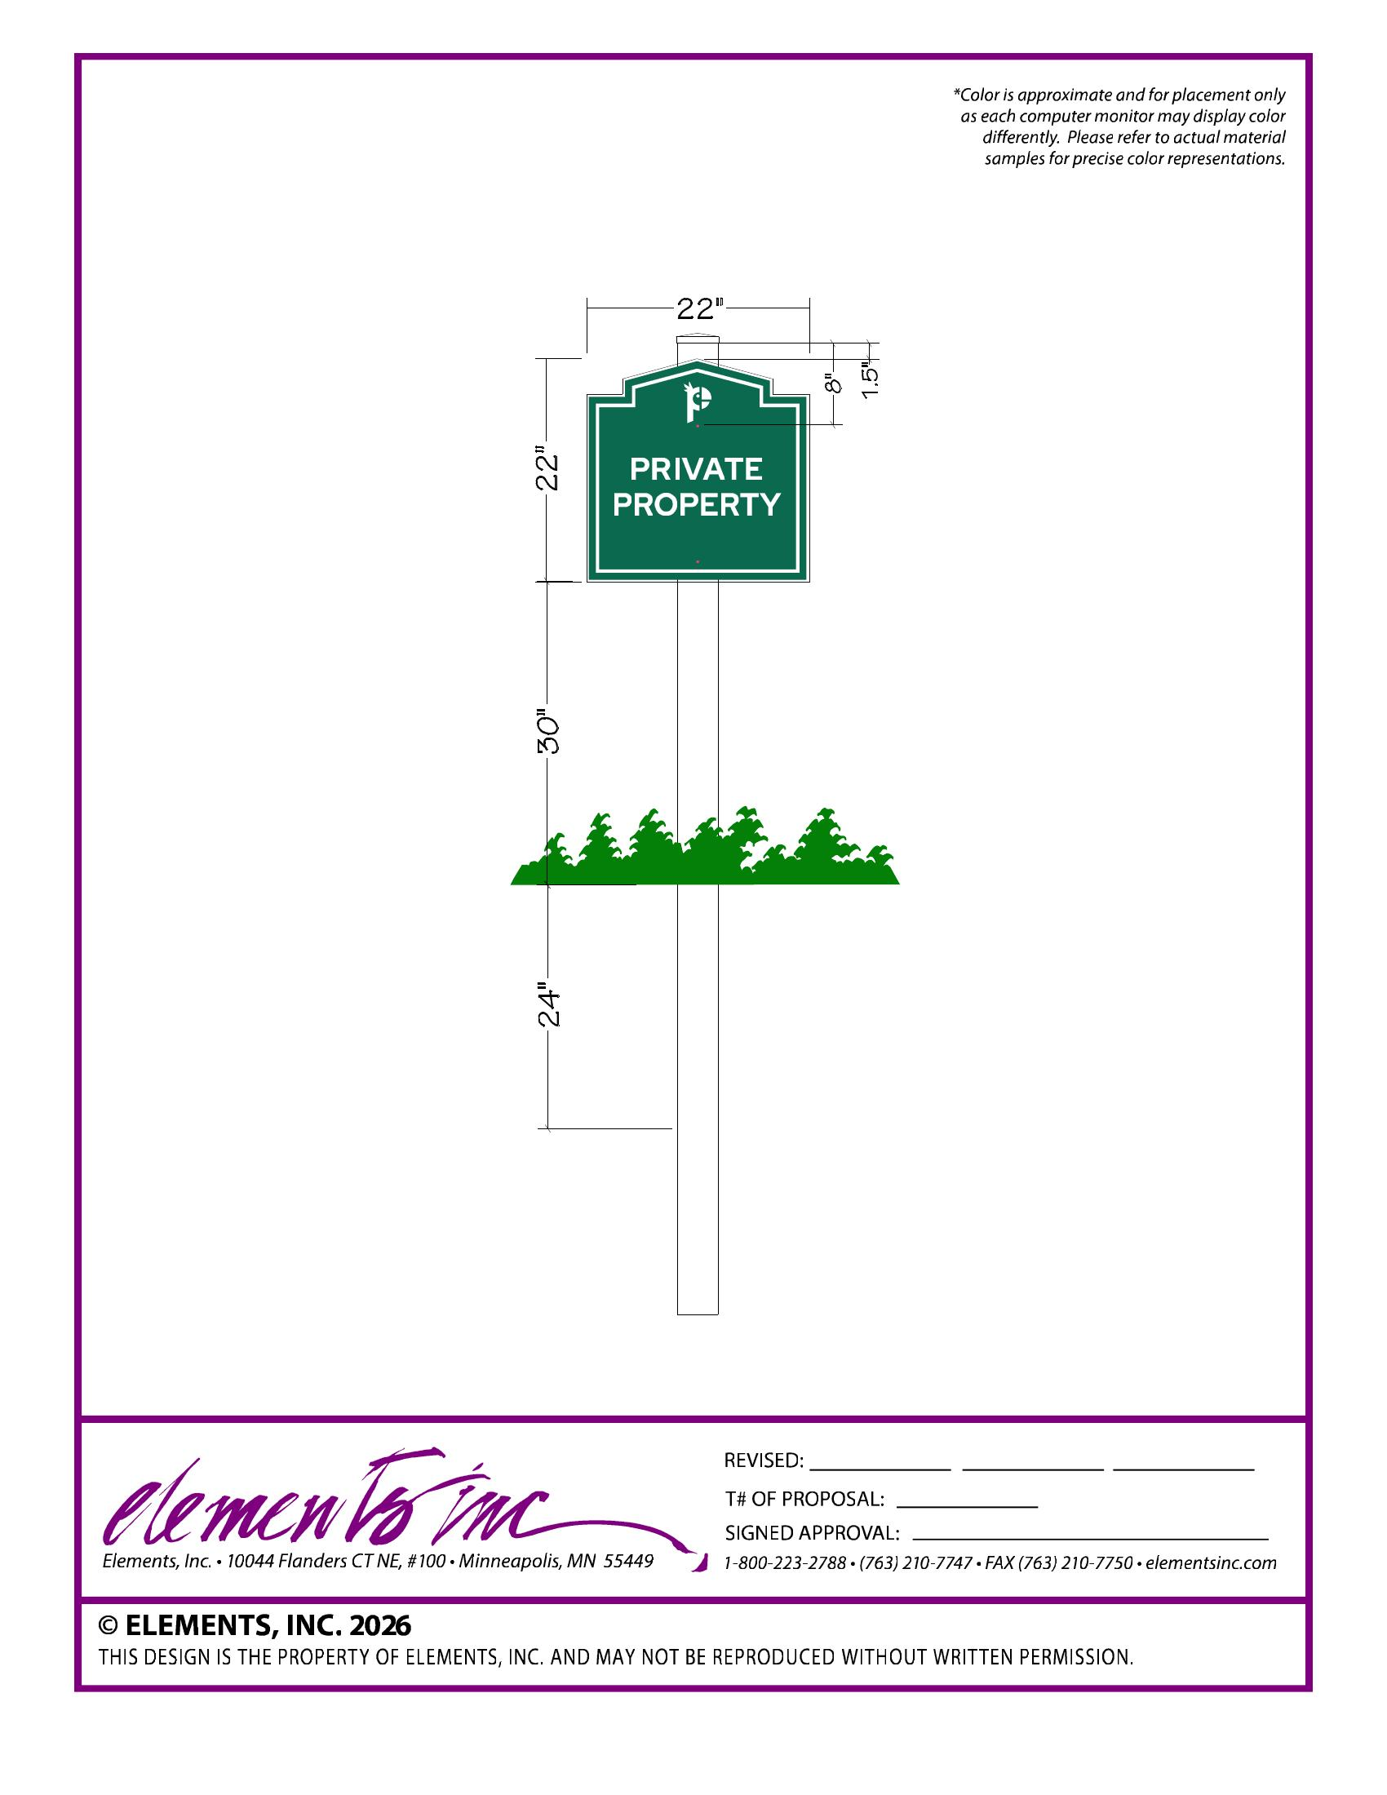
Private Property Sign — 22"W × 22"H, 30" above grade, 24" below grade

Sign Type 4 — Speed Limit Sign

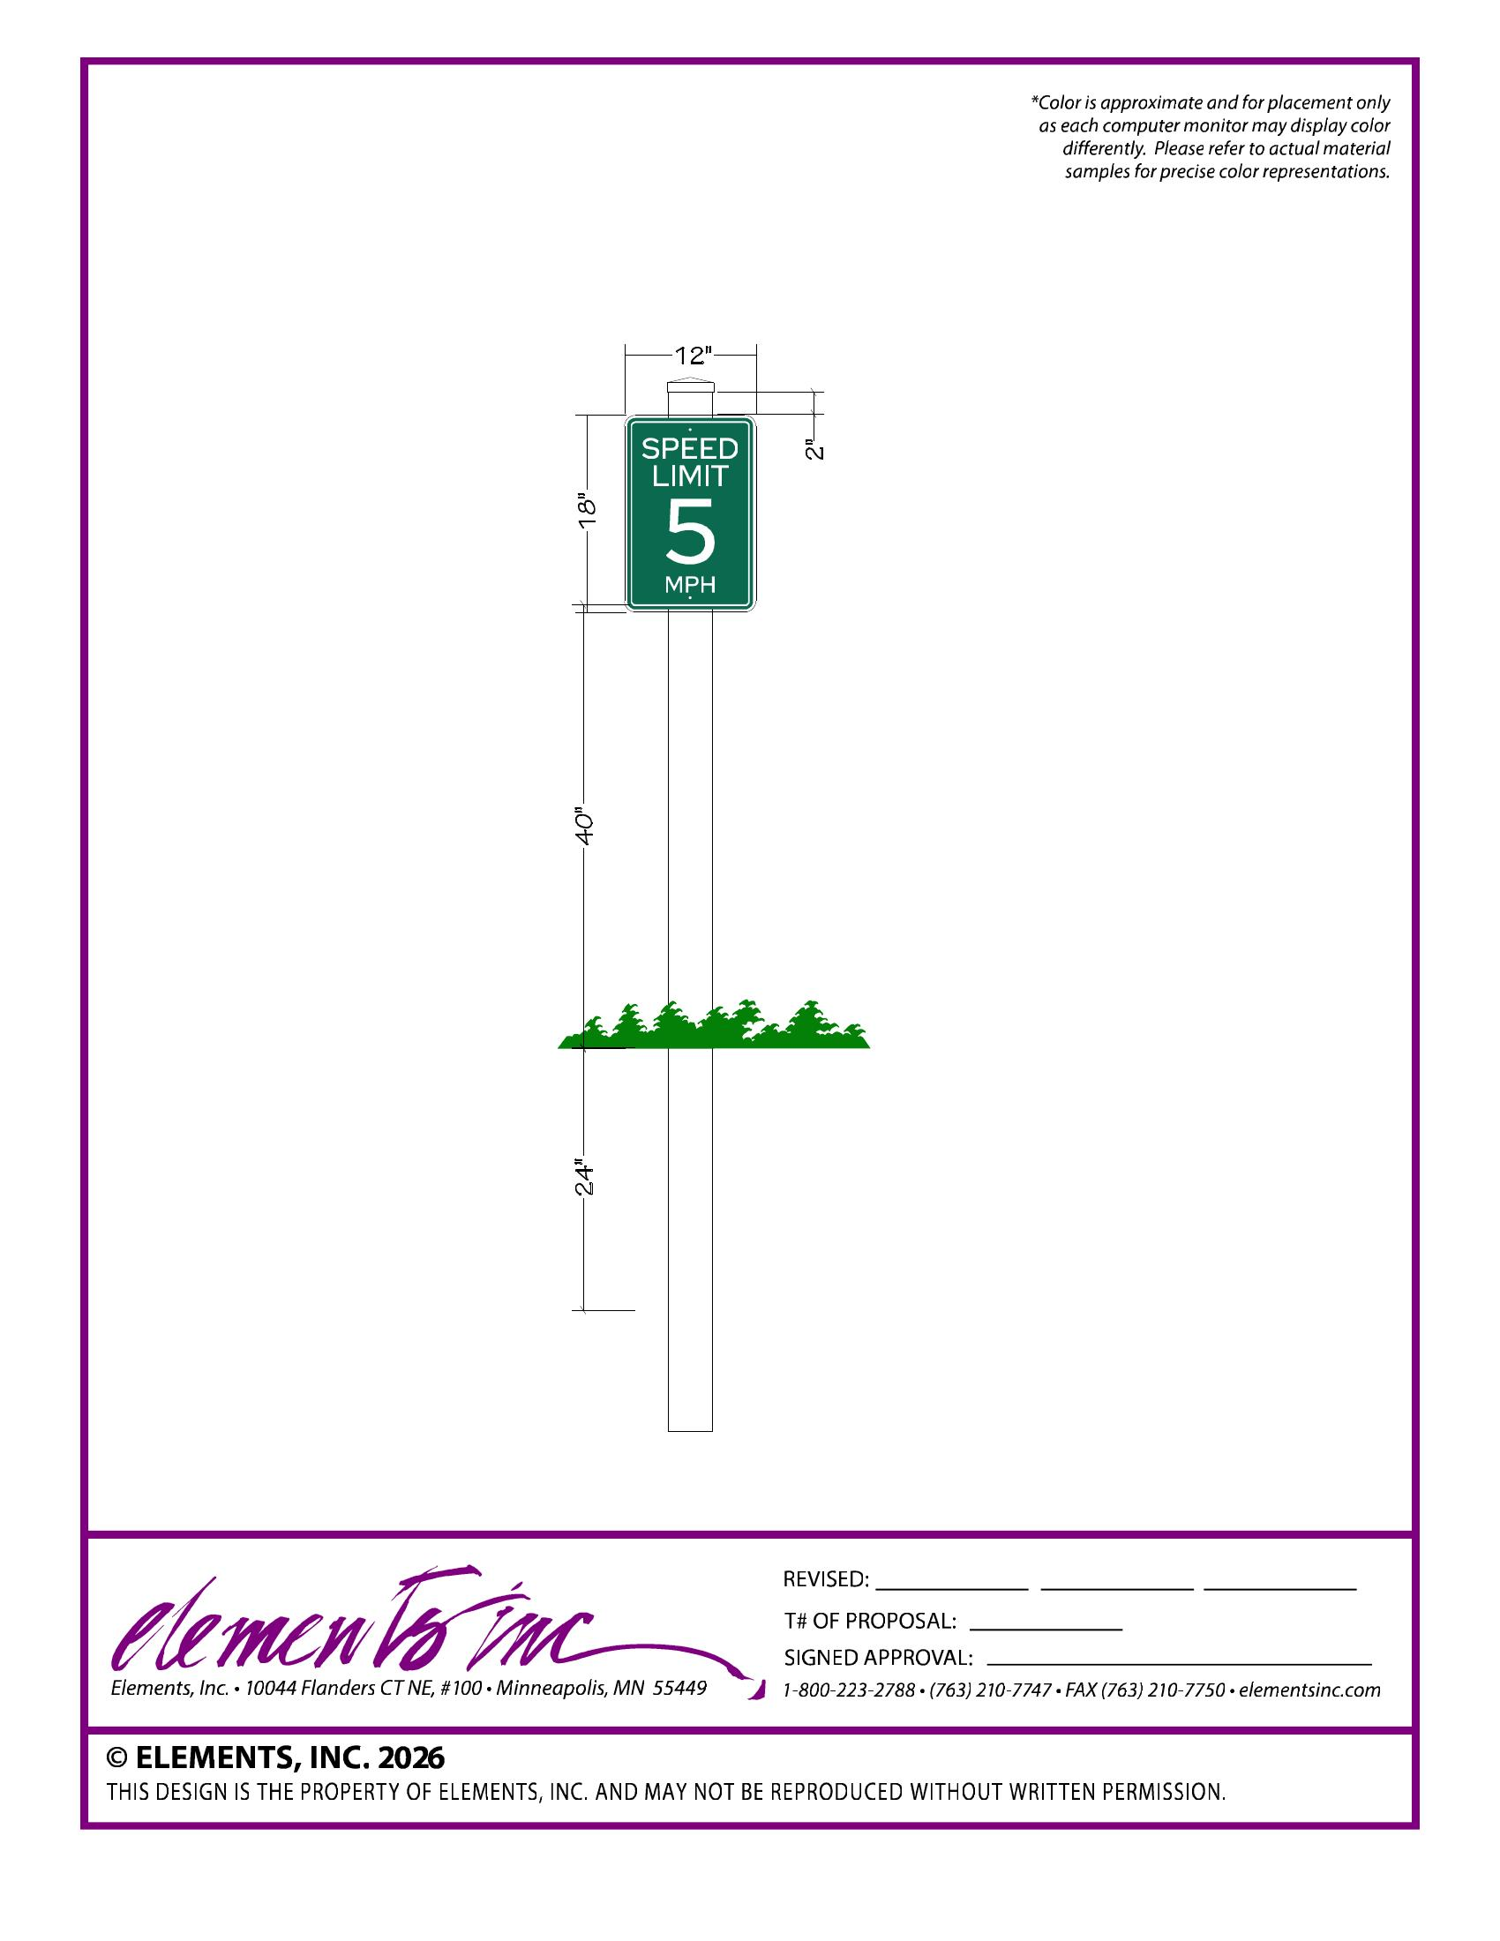
Speed Limit Sign — 12"W × 18"H, 40" above grade, 24" below grade

Sign Type 5 — Street / Wayfinding Blade Sign

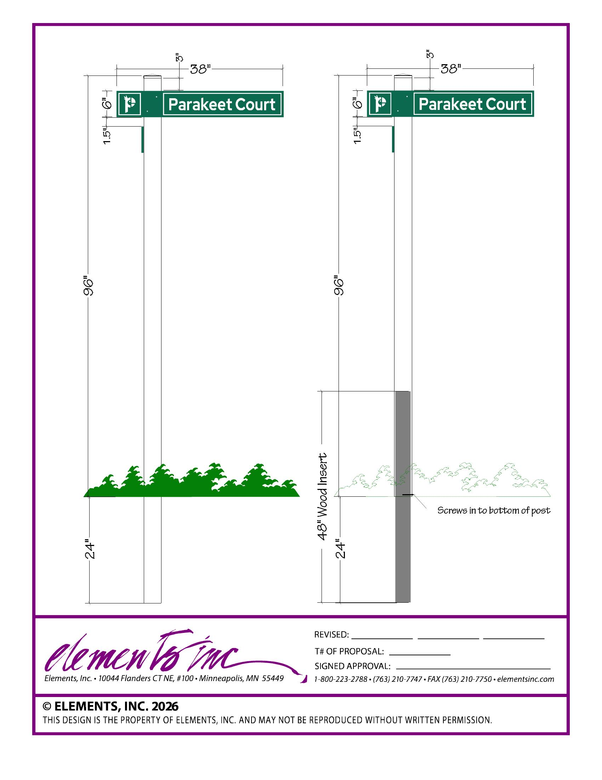
Street Blade Sign — 38"W × 6"H blade, 96" above grade, 24" below grade. Optional 48" wood insert.
Section 2 — Hardscape Specification

A raised planter surround is required at every main entry monument sign. Select either the Gray or Taupe/Beige color scheme to complement the community's existing aesthetics.
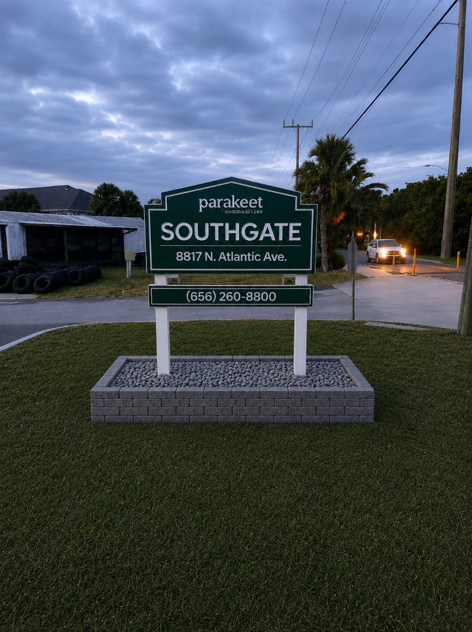 | 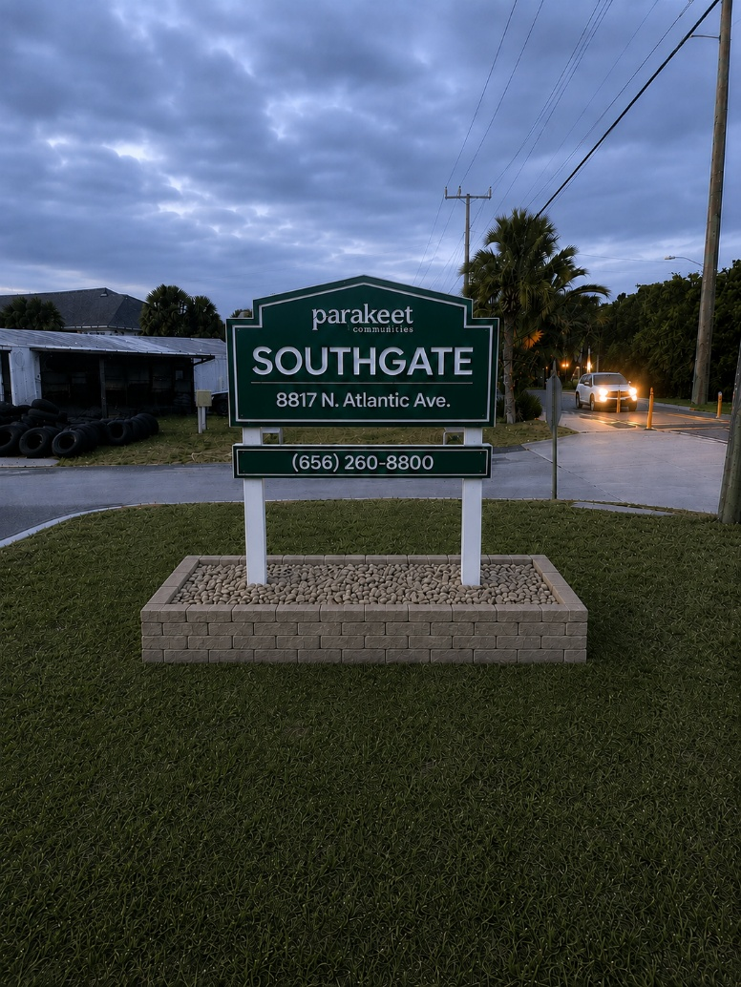

Gray Stone (Option A) | Taupe/Beige Stone (Option B)

Overall Planter Dimensions
Item | Measurement
Outside Length | 9'-0" (108")
Outside Width | 4'-6" (54")
Finished Wall Height | 12" (2 courses)
Wall Thickness | 8"
Interior Stone Area | ≈ 44 sq ft

Center the wall beneath the sign on all sides. Adjust field dimensions as needed.

Retaining Wall Block

Style: Split-face concrete retaining wall block, 4"H × 8"W × 12"D approx.
Color: Gray or Taupe/Beige to match selected color scheme.
Approved products: Keystone Compac, Belgard Diamond Pro Mini, Pavestone Retaining Wall Block, Oldcastle Mini Beltis.
Item | Quantity
Perimeter | ≈ 27 linear feet
Courses | 2
Block Quantity | 60–65 blocks (includes 10% waste)

Base Preparation

- Excavate approximately 10 inches below finished grade.
- Install geotextile fabric.
- Place 6 inches of compacted #57 stone.
- Finish with 1 inch of leveling screenings.
- Compact every 2 inches during fill.
Wall Installation

First course: Set completely level. Embed approximately 1" below surrounding grass grade on compacted stone base.
Second course: Running bond pattern — vertical joints must fall at center of block below.
Adhesive between courses: Loctite PL Premium, SRW Vertical Instant Lock, or Sakrete Landscape Adhesive.
Interior Fill

- Install landscape fabric over compacted soil.
- Fill with 1½" washed river rock matching wall color. Target depth: 4".
- Keep rock ≈ 1" below top of wall for a clean finished look.
- Place #57 drainage stone (6" wide, full wall height) behind inside face of wall.

Section 3 — Material Summary

Quantities below are per sign installation and include waste allowance. Verify against field measurements before ordering.
Material | Approx. Quantity
Retaining Wall Block | 60–65 blocks
#57 Base Stone | 1.2 cubic yards
Decorative River Rock (Gray or Taupe/Beige) | 0.5 cu yd (≈ 900–1,000 lbs)
Geotextile Fabric | 60 sq ft
Landscape Block Adhesive | 4 tubes
Leveling Screenings | 0.15 cubic yard
#57 Drainage Stone (behind wall) | 0.20 cubic yard

Construction Notes

- Center the planter perfectly beneath the monument sign.
- Finished wall height: 12" (2 courses).
- Maintain minimum 1% slope away from posts to prevent standing water.
- Use running bond pattern — stagger vertical joints every course.
- Before digging: verify no irrigation lines or electrical conduits are in the excavation area.
- Florida sandy soils: extend stone base 6" beyond wall footprint on all sides for stability.

Section 4 — Landscaping & Visual Interest

One landscaping option is required at every main entry sign. Select the option that best fits the community's maintenance capacity and aesthetic goals.
Option 1 — Permanent Plants | Low Maintenance

Drought-tolerant, zone-specific species growing no taller than 24". Plant 2–4 specimens in the stone field, spaced equally in front of the sign posts. Use the post spacing as a centering guide. Occasional trimming required.
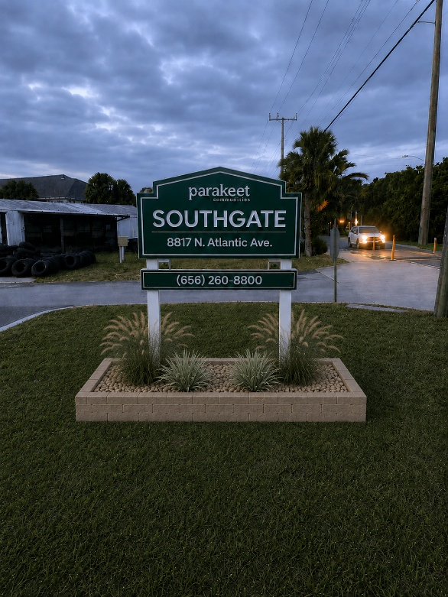
Option 1 — Ornamental grasses planted in stone field (Southgate reference)

